**BAB IV**

**PERANCANGAN SISTEM**

**4.1 Perancangan Sistem**

Perancangan sistem merupakan tahapan dari siklus pengembangan sistem yang didefinisakan dari kebutuhan-kebutuhan fungsional dan persiapan untuk rancang bangun implementasi yang menggambarkan bagaimana suatu sistem dibentuk. Perancangan sistem ini bertujuan untuk memetakan setiap kebutuhan sistem, sehingga proses pembangunannya dapat berjalan dengan baik.

**4.2 Metode Perancangan Sistem**

**4.2.1 Use Case Diagram**



**Gambar 4.1** *Use Case Diagram*

**4.2.2 Use Case Spesification**

1. Use Case Login

|  |  |
| --- | --- |
| No. | 1 |
| Name | *Login* |
| Purpose | Menentukan hak akses kepada setiap pengguna sistem. Seluruh fungsi-fungsi dalam sistem akan mengharuskan semua *user* untuk melewati proses ini. |
| Actor | Admin, Kaprodi atau Penyusun Borang |
| Pre-condition | *User* dalam keadaan *logout*. |
| Post-condition | *User* dapat masuk ke dalam sistem dan menggunakan hak aksesnya |
| Scenario | 1) Aplikasi menampilkan form *Login* ketika aplikasi pertama kali dijalankan. 2) *User* menginputkan *username* dan *password*. 3) *Username* dan *password* *valid*, sistem menampilkan halaman utama dengan beberapa menu data borang. |
| Alternatif Scenario | 1) Jika *username* dan *password* tidak valid maka pengguna tidak dapat mengakses sistem. 2) *User* harus menginputkan kembali *username* dan *password* |
| Requirment | Membutuhkan data *user* yang mempunyai hak untuk *login* |

**Tabel 4.1** *Use Case Login*

1. Use Case Kelola Data Fakultas

|  |  |
| --- | --- |
| No. | 2 |
| Name | Kelola Data Fakultas |
| Purpose | Mengelola data Fakultas, fungsi dalam *use case* ini yaitu CRUD (*create, read, update, delete*) |
| Actor | Admin |
| Pre-condition | Admin dalam keadaan *login* |
| Post-condition | Data Fakultas sudah dimanipulasi |
| Scenario | 1. Tambah Data 2. Admin memilih menu Data Fakultas 3. Sistem memuat dan menampilkan data fakultas yang terdapat pada sistem. 4. Admin mengklik button tambah. 5. Sistem menampilkan form tambah data fakultas. 6. Admin mengisi data fakultas. 7. Admin mengklik button simpan. 8. Sistem menyimpan data Fakultas 9. Ubah Data 10. Admin memilih menu Data Fakultas 11. Sistem memuat dan menampilkan data fakultas yang terdapat pada sistem 12. Admin mengklik button ubah 13. Sistem memuat data Fakultas dan menampilkan form ubah data Fakultas 14. Admin mengisi data Fakultas 15. Admin mengklik button ubah 16. Sistem mengubah data Fakultas 17. Hapus Data 18. Admin memilih menu Data Fakultas 19. Sistem memuat dan menampilkan data fakultas yang terdapat pada system 20. Admin mengklik button hapus 21. Sistem menampilkan konfirmasi hapus data Fakultas 22. Admin memilih tombol ‘Ya’ 23. Sistem menghapus data Fakultas |
| Alternatif Scenario | Tidak ada |
| Requirment | Admin telah melakukan *login* terlebih dahulu |

**Tabel 4.2** *Use Case* Kelola Data Fakultas

1. Use Case Kelola Data Program Studi

|  |  |
| --- | --- |
| No. | 3 |
| Name | Kelola Data Program Studi |
| Purpose | Mengelola data Program Studi, fungsi dalam *use case* ini yaitu CRUD (*create, read, update, delete*) |
| Actor | Admin |
| Pre-condition | Admin dalam keadaan *login* |
| Post-condition | Data Program Studi sudah dimanipulasi |
| Scenario | 1. Tambah Data 2. Admin memilih menu Data Program Studi 3. Sistem memuat dan menampilkan data Program Studi yang terdapat pada sistem. 4. Admin mengklik button tambah. 5. Sistem menampilkan form tambah data Program Studi. 6. Admin mengisi data Program Studi. 7. Admin mengklik button simpan. 8. Sistem menyimpan data Program Studi 9. Ubah Data 10. Admin memilih menu Data Program Studi 11. Sistem memuat dan menampilkan data Program Studi yang terdapat pada sistem 12. Admin mengklik button ubah 13. Sistem memuat data Program Studi dan menampilkan form ubah data Program Studi 14. Admin mengisi data Program Studi 15. Admin mengklik button ubah 16. Sistem mengubah data Program Studi 17. Hapus Data 18. Admin memilih menu Data Program Studi 19. Sistem memuat dan menampilkan data Program Studi yang terdapat pada sistem 20. Admin mengklik button hapus 21. Sistem menampilkan konfirmasi hapus data Program Studi 22. Admin memilih tombol ‘Ya’ 23. Sistem menghapus data Program Studi |
| Alternatif Scenario | Tidak ada |
| Requirment | Admin telah melakukan *login* terlebih dahulu |

**Tabel 4.3** *Use Case* Kelola Data Program Studi

1. Use Case Kelola Data User

|  |  |
| --- | --- |
| No. | 4 |
| Name | Kelola Data *User* |
| Purpose | Mengelola data *user*, fungsi dalam *use case* ini yaitu tambah data dan hapus data *user*. |
| Actor | Admin |
| Pre-condition | Admin dalam keadaan *login* |
| Post-condition | Data user sudah dimanipulasi |
| Scenario | 1. Tambah Data 2. Admin memilih menu data *user* 3. Sistem memuat dan menampilkan data *user* yang terdapat pada sistem. 4. Admin mengklik button tambah. 5. Sistem menampilkan form tambah data *user* 6. Admin mengisi data *user* 7. Admin mengklik button simpan. 8. Sistem menyimpan data *user* 9. Hapus Data 10. Admin memilih menu data *user* 11. Sistem memuat dan menampilkan data *user* yang terdapat pada sistem 12. Admin mengklik button hapus 13. Sistem menampilkan konfirmasi hapus data *user* 14. Admin memilih tombol ‘Ya’ 15. Sistem menghapus data *user* |
| Alternatif Scenario | *User* yangtidak terdaftar di data program studi, maka admin menambahkan terlebih dulu ke dalam data program studi |
| Requirment | Saat admin membuat akun untuk *user*, *user* harus sudah terdaftar di data program studi |

**Tabel 4.4** *Use Case* Kelola Data User

1. Use Case Kelola Data Borang Akreditasi

|  |  |
| --- | --- |
| No. | 5 |
| Name | Kelola data borang akreditasi |
| Purpose | Mengelola data borang akreditasi, fungsi dalam *use* *case* ini yaitu tambah data, ubah data, hapus data, dan *export* data ke *excel* |
| Actor | Penyusun borang |
| Pre-condition | Penyusun borang dalam keadaan *login* |
| Post-condition | Data borang sudah dimanipulasi |
| Scenario | 1. Tambah data 2. Penyusun borang memilih menu data borang akreditasi 3. Sistem memuat dan menampilkan data borang yang terdapat pada sistem. 4. Penyusun borang mengklik button tambah. 5. Sistem menampilkan data borang 6. Penyusun borang mengklik button simpan. 7. Sistem menyimpan data borang 8. Ubah data 9. Penyusun borang memilih menu data borang akreditasi 10. Sistem memuat dan menampilkan data borang yang terdapat pada sistem. 11. Penyusun borang mengklik button ubah 12. Sistem memuat data borang dan menampilkan form ubah data borang 13. Penyusun borang mengisi data borang 14. Penyusun borang memilih button ubah 15. Sistem mengubah data borang 16. Hapus data 17. Penyusun borang memilih menu data borang akreditasi 18. Sistem memuat dan menampilkan data borang yang terdapat pada sistem. 19. Penyusun borang memilih link hapus 20. Sistem menampilkan konfirmasi hapus data borang 21. Penyusun borang memilih button ‘Ya’ 22. Sistem menghapus data borang 23. *Export* data ke *excel* 24. Penyusun borang menu data borang akreditasi 25. Sistem memuat dan menampilkan data borang yang terdapat pada sistem. 26. Penyusun borang memilih button *Export* data ke *excel* 27. Sistem menampilkan konfirmasi Export data ke *excel* 28. Penyusun borang memilih button ‘Ya’ 29. Sistem mengexport data ke dalam bentuk *excel*. |
| Alternatif Scenario | Tidak ada |
| Requirment | Tidak ada |

**Tabel 4.5** *Use Case* Kelola Data Borang Akreditasi

* + 1. **Activity Diagram**

1. Activity Login



**Gambar 4.2** *Activity* Diagram Login

1. Activity Kelola Data Fakultas



**Gambar 4.3** *Activity* Kelola Data Fakultas

1. Activity Kelola Data Program Studi



**Gambar 4.4** *Activity* Kelola Program Studi

1. Activity Kelola Data User



**Gambar 4.5** *Activity* Kelola Data *User*

1. Activity Kelola Data Borang Akreditasi



**Gambar 4.6** *Activity* Kelola Data Borang Akreditasi

1. Activity Tambah Data



**Gambar 4.7** *Activity* Tambah Data

1. Activity Ubah data



**Gambar 4.8** *Activity* Ubah Data

1. Activity Hapus data



**Gambar 4.9** *Activity* Hapus Data

1. Activity Tambah data borang



**Gambar 4.10** *Activity* Tambah Data Borang

1. Activity Export Data



**Gambar 4.11** *Activity Export* Data

* + 1. **Sequence Diagram**

1. Sequence Login



**Gambar 4.12** *Sequence Diagram Login*

1. Sequence Kelola Data Fakultas
   1. Sequence Tambah Data Fakultas



**Gambar 4.13** *Sequence Diagram* Tambah Data Fakultas

* 1. Sequence Ubah Data Fakultas



**Gambar 4.14** *Sequence Diagram* Ubah Data Fakultas

* 1. Sequence Hapus Data Fakultas



**Gambar 4.15** *Sequence Diagram* Hapus Data Fakultas

1. Sequence Kelola Program Studi
2. Sequence Tambah Data Program Studi



**Gambar 4.16** *Sequence Diagram* Tambah Data Program Studi

1. Sequence Ubah Data Program Studi



**Gambar 4.17** *Sequence Diagram* Ubah Data Program Studi

1. Sequence Hapus Data Program Studi



**Gambar 4.18** *Sequence Diagram* Hapus Data Program Studi

1. Sequence Kelola Data User
2. Sequence Tambah Data User



**Gambar 4.19** *Sequence Diagram* Tambah Data *User*

1. Sequence Hapus Data User



**Gambar 4.20** *Sequence Diagram* Hapus Data *User*

1. Sequence Kelola Data Borang
   1. Sequence Tambah Data Borang (Ambil Data)



**Gambar 4.21** *Sequence Diagram* Tambah Data Borang

* 1. Sequence Ubah Data Borang



**Gambar 4.22** *Sequence Diagram* Ubah Data Borang

* 1. Sequence Diagram Hapus Data Borang



**Gambar 4.23** *Sequence Diagram* Hapus Data Borang

* 1. Sequence Diagram *Export* Data



**Gambar 4.24** *Sequence Diagram Export* Data

**4.2.5 Class Diagram**



**Gambar 4.25** *Class Diagram*

**4.3 Perancangan Basis Data**

**4.3.1 Skema Relasi Basis Data**

Db_Perpustakaan

Db_Keuangan

Db_HRD

Db_akademik

Db_Logistik

Db_Borang

**Gambar 4.26** Skema Relasi Basis Data

**4.3.3 Deskripsi Tabel**

1. Tabel apd_a311

Fungsi : menyimpan data mahasiswa reguler

*Primary Key* : -

Struktur tabel :

|  |  |  |  |  |
| --- | --- | --- | --- | --- |
| No. | Nama Field | Tipe | Lebar | Keterangan |
| 1. | tahunAkd | Int | 11 |  |
| 2. | dayaTampung | Int | 11 |  |
| 3. | jcalonMhsIkutSeleksi | Int | 11 |  |
| 4. | jcalonMhsLulusSeleksi | Int | 11 |  |
| 5. | jMhsBaruRegBukanTransfer | Int | 11 |  |
| 6. | jMhsBaruTransfer | Int | 11 |  |
| 7. | jtotalMhsRegBukanTransfer | Int | 11 |  |
| 8. | jtotalMhsTransfer | Int | 11 |  |
| 9. | jLulusRegBukantransfer | Int | 11 |  |
| 10. | jLulusTransfer | Int | 11 |  |
| 11. | IPKLulusRegMin | Double |  |  |
| 12. | IPKLulusRegRat | Double |  |  |
| 13. | IPKLulusRegMax | Double |  |  |
| 14. | persenIPKKurang275 | Double |  |  |
| 15. | persenIPK275350 | Double |  |  |
| 16. | persenIPKLebih350 | Double |  |  |

**Tabel 4.1** Deskripsi Tabel apd_a311

1. Tabel apd_a313

Fungsi : menyimpan data jumlah mahasiswa regular.

*Primary Key* : -

Struktur tabel :

|  |  |  |  |  |
| --- | --- | --- | --- | --- |
| No. | Nama Field | Tipe | Lebar | Keterangan |
| 1. | tahunMasuk | Int | 4 |  |
| 2. | TS6 | Smallint | 6 |  |
| 3. | TS5 | Smallint | 11 |  |
| 4. | TS4 | Smallint | 11 |  |
| 5. | TS3 | Smallint | 11 |  |
| 6. | TS2 | Smallint | 11 |  |
| 7. | TS1 | Smallint | 11 |  |
| 8. | TS | Smallint | 11 |  |
| 9. | jumlahLulusan | Smallint | 11 |  |

**Tabel 4.2** Deskripsi Tabel apd_a313

1. Tabel apd_a341

Fungsi : menyimpan data evaluasi kinerja lulusan

*Primary Key* : -

Struktur tabel :

|  |  |  |  |  |
| --- | --- | --- | --- | --- |
| No. | Nama Field | Tipe | Lebar | Keterangan |
| 1. | jenisKemampuan | Varchar | 50 |  |
| 2. | sangatBaik | Double |  |  |
| 3. | baik | Double |  |  |
|  | cukup | Double |  |  |
|  | kurang | Double |  |  |
|  | rencanaTindakLanjut | Double |  |  |

**Tabel 4.3** Deskripsi Tabel a341

1. Tabel apd_a345

Fungsi : menyimpan data lembaga yang memesan lulusan untuk bekerja.

*Primary Key* : -

Struktur tabel :

|  |  |  |  |  |
| --- | --- | --- | --- | --- |
| No. | Nama Field | Tipe | Lebar | Keterangan |
| 1. | tahun | Int | 11 |  |
| 2. | jLulusWisuda | Int | 11 |  |
| 3. | Lembaga/Instansi | Varchar | 50 |  |
| 4. | jLulusDipesan | Int | 11 |  |
| 5. | jLulusDiterima | Int | 11 |  |

**Tabel 4.4** Deskripsi Tabel apd_a345

1. Tabel apd_a431

Fungsi : menyimpan data dosen tetap yang bidang keahliannya sesuai bidang PS.

*Primary Key* : -

Struktur tabel :

|  |  |  |  |  |
| --- | --- | --- | --- | --- |
| No. | Nama Field | Tipe | Lebar | Keterangan |
| 1. | namaDosentetap | Varchar | 50 |  |
| 2. | NIDN | Char | 18 |  |
| 3. | tglLahir | Date |  |  |
| 4. | jabatanAkd | Varchar | 50 |  |
| 5. | sertifikasi | Char | 5 |  |
| 6. | s1gelar | Varchar | 30 |  |
| 7. | s1PTAsal | Varchar | 30 |  |
| 8. | s1bidangKeahlian | Varchar | 30 |  |
| 9. | s2gelar | Varchar | 30 |  |
| 10. | s2PTAsal | Varchar | 30 |  |
| 11. | s2bidangKeahlian | Varchar | 30 |  |
| 12. | s3gelar | Varchar | 30 |  |
| 13. | s3PTAsal | Varchar | 30 |  |
| 14. | s3bidangKeahlian | Varchar | 30 |  |
| 15. | kpGelar | Varchar | 30 |  |
| 16. | kpPengakuan | Varchar | 30 |  |
| 17. | kpBidangKeahlian | Varchar | 30 |  |

**Tabel 4.5** Deskripsi Tabel apd_a431

1. Tabel apd_a432

Fungsi : menyimpan data dosen tetap yang bidang keahliannya diluar bidang PS.

*Primary Key* : -

Struktur tabel :

|  |  |  |  |  |
| --- | --- | --- | --- | --- |
| No. | Nama Field | Tipe | Lebar | Keterangan |
| 1. | namaDosentetap | Varchar | 50 |  |
| 2. | NIDN | Char | 18 |  |
| 3. | tglLahir | Date |  |  |
| 4. | jabatanAkd | Varchar | 50 |  |
| 5. | sertifikasi | Char | 5 |  |
| 6. | s1bidangKeahlian | Varchar | 30 |  |
| 7. | s1PTAsal | Varchar | 30 |  |
| 8. | s1gelar | Varchar | 30 |  |
| 9. | s2bidangKeahlian | Varchar | 30 |  |
| 10. | s2PTAsal | Varchar | 30 |  |
| 11. | s2gelar | Varchar | 30 |  |
| 12. | s3bidangKeahlian | Varchar | 30 |  |
| 13. | s3PTAsal | Varchar | 30 |  |
| 14. | s3gelar | Varchar | 30 |  |
| 15. | kpGelar | Varchar | 30 |  |
| 16. | kpPengakuan | Varchar | 30 |  |
| 17. | kpBidangKeahlian | Varchar | 30 |  |

**Tabel 4.6** Deskripsi Tabel apd_a432

1. Tabel apd_a433

Fungsi : menyimpan data aktivitas dosen tetap yang bidang keahliannya sesuai dengan PS.

*Primary Key* : -

Struktur tabel :

|  |  |  |  |  |
| --- | --- | --- | --- | --- |
| No. | Nama Field | Tipe | Lebar | Keterangan |
| 1. | namaDosnTetap | Varchar | 50 |  |
| 2. | sksPengajaranPTsendiri | Int | 11 |  |
| 3. | sksPengajaranLS | Int | 11 |  |
| 4. | sksPengajaranPTLain | Int | 11 |  |
| 5. | sksPenelitian | Int | 11 |  |
| 6. | sksAbdiMas | Int | 11 |  |
| 7. | sksManajemenPTsendiri | Int | 11 |  |
| 8. | sksManajemenPTLain | Int | 11 |  |
| 9. | jumlahSKS | Int | 11 |  |

**Tabel 4.7** Deskripsi Tabel apd_a433

1. Tabel apd_a434

Fungsi : menyimpan data aktivitas mengajar dosen tetap yang bidang keahliannya sesuai dengan PS

*Primary Key* : -

Struktur tabel :

|  |  |  |  |  |
| --- | --- | --- | --- | --- |
| No. | Nama Field | Tipe | Lebar | Keterangan |
| 1. | namaDosentetap | Varchar | 50 |  |
| 2. | bidangKeahlian | Varchar | 30 |  |
| 3. | kodeMK | Char | 6 |  |
| 4. | namaMK | Varchar | 30 |  |
| 5. | jumlahKelas | Int | 11 |  |
| 6. | jDirencanakan | Int | 11 |  |
| 7. | jDilaksanakan | Int | 11 |  |

**Tabel 4.8** Deskripsi Tabel apd_a434

1. Tabel apd_a435

Fungsi : menyimpan data aktivitas mengajar dosen tetap yang bidang keahliannya diluar dengan PS

*Primary Key* : -

Struktur tabel :

|  |  |  |  |  |
| --- | --- | --- | --- | --- |
| No. | Nama Field | Tipe | Lebar | Keterangan |
| 1. | namaDosentetap | Varchar | 50 |  |
| 2. | kodeMK | Char | 6 |  |
| 3. | namaMK | Varchar | 30 |  |
| 4. | jumlahKelas | Int | 11 |  |
| 5. | jDirencanakan | Int | 11 |  |
| 6. | jDilaksanakan | Int | 11 |  |

**Tabel 4.9** Deskripsi Tabel apd_a435

1. Tabel apd_a441

Fungsi : menyimpan data dosen tidak tetap.

*Primary Key* : -

Struktur tabel :

|  |  |  |  |  |
| --- | --- | --- | --- | --- |
| No. | Nama Field | Tipe | Lebar | Keterangan |
| 1. | namaDosenTidakTetap | Varchar | 50 |  |
| 2. | NIDN | Varchar | 18 |  |
| 3. | tglLahir | Date |  |  |
| 4. | jabatanAkd | Varchar | 30 |  |
| 5. | sertifikasi | Char | 6 |  |
| 6. | s1PTAsal | Varchar | 30 |  |
| 7. | s1BidangKeahlian | Varchar | 30 |  |
| 8. | s1gelar | Varchar | 30 |  |
| 9. | s2PTAsal | Varchar | 30 |  |
| 10 | s2BidangKeahlian | Varchar | 30 |  |
| 11. | s2gelar | Varchar | 30 |  |
| 12. | s3PTAsal | Varchar | 30 |  |
| 13. | s3BidangKeahlian | Varchar | 30 |  |
| 14. | s3gelar | Varchar | 30 |  |

**Tabel 4.10** Deskripsi Tabel apd_a441

1. Tabel apd_a442

Fungsi : menyimpan data aktivitas mengajar dosen tidak tetap

*Primary Key* : -

Struktur tabel :

|  |  |  |  |  |
| --- | --- | --- | --- | --- |
| No. | Nama Field | Tipe | Lebar | Keterangan |
| 1. | namaDosenTidakTetap | Varchar | 50 |  |
| 2. | kodeMK | Char | 6 |  |
| 3. | namaMK | Varchar | 30 |  |
| 4. | jumlahSKS | Int | 11 |  |
| 5. | jDirencanakan | Int | 11 |  |
| 6. | jDilaksanakan | Int | 11 |  |

**Tabel 4.11** Deskripsi Tabel apd_a442

1. Tabel apd_a451

Fungsi : menyimpan data kegiatan tenaga ahli/pakar (tidak termasuk dosen tetap)

*Primary Key* : -

Struktur tabel :

|  |  |  |  |  |
| --- | --- | --- | --- | --- |
| No. | Nama Field | Tipe | Lebar | Keterangan |
| 1. | namaTenagaAhli/Pakar | Varchar | 50 |  |
| 2. | instansi/jabatan | Varchar | 30 |  |
| 3. | namaJudulKegiatan | Varchar | 50 |  |
| 4. | tahun | Int | 4 |  |

**Tabel 4.12** Deskripsi Tabel apd_a451

1. Tabel apd_a452

Fungsi : menyimpan data peningkatan kemampuan dosen tetap melalui tugas belajar.

*Primary Key* : -

Struktur tabel :

|  |  |  |  |  |
| --- | --- | --- | --- | --- |
| No. | Nama Field | Tipe | Lebar | Keterangan |
| 1. | namaDosenTetap | Varchar | 50 |  |
| 2. | jenjangPendidikan | Varchar | 30 |  |
| 3. | bidangStudi | Varchar | 15 |  |
| 4. | perguruanTinggi | Varchar | 30 |  |
| 5. | negara | Varchar | 15 |  |
| 6. | tahunMulaiStudi | Char | 4 |  |

**Tabel 4.13** Deskripsi Tabel apd_a452

1. Tabel apd_a453

Fungsi : menyimpan data kegiatan dosen tetap dalam seminar dll.

*Primary Key* : -

Struktur tabel :

|  |  |  |  |  |
| --- | --- | --- | --- | --- |
| No. | Nama Field | Tipe | Lebar | Keterangan |
| 1. | namaDosenTetap | Varchar | 50 |  |
| 2. | jenisKegiatan | Varchar | 30 |  |
| 3. | tempat | Varchar | 30 |  |
| 4. | tahun | Int | 4 |  |
| 5. | penyaji | Char | 1 |  |
| 6. | peserta | Char | 1 |  |

**Tabel 4.14** Deskripsi Tabel apd_a453

1. Tabel apd_a455

Fungsi : menyimpan data keikutsertaan dosen tetap dalam organisasi keilmuan/profesi.

*Primary Key* : -

Struktur tabel :

|  |  |  |  |  |
| --- | --- | --- | --- | --- |
| No. | Nama Field | Tipe | Lebar | Keterangan |
| 1. | namaDosen | Varchar | 50 |  |
| 2. | namaOrganisasi | Varchar | 50 |  |
| 3. | tahunAwal | Int | 4 |  |
| 4. | tahunAkhir | Int | 4 |  |
| 5. | tingkatInternasional | Varchar | 30 |  |
| 6. | tingkatNasional | Varchar | 30 |  |
| 7. | tingkatLokal | Varchar | 30 |  |

**Tabel 4.15** Deskripsi Tabel apd_a455

1. Tabel apd_a461

Fungsi : menyimpan data tenaga pendidikan.

*Primary Key* : -

Struktur tabel :

|  |  |  |  |  |
| --- | --- | --- | --- | --- |
| No. | Nama Field | Tipe | Lebar | Keterangan |
| 1. | jenisTenagaKependidikan | Varchar | 30 |  |
| 2. | jumlahS3 | Int | 11 |  |
| 3. | jumlahS2 | Int | 11 |  |
| 4. | jumlahS1 | Int | 11 |  |
| 5. | jumlahD4 | Int | 11 |  |
| 6. | jumlahD3 | Int | 11 |  |
| 7. | jumlahD2 | Int | 11 |  |
| 8. | jumlahD1 | Int | 11 |  |
| 9. | jumlahSMA/SMK | Int | 11 |  |
| 10. | unitKerja | Varchar | 30 |  |

**Tabel 4.16** Deskripsi Tabel apd_a461

1. Tabel apd_a5121

Fungsi : menyimpan data struktur kurikulum berdasarkan urutan MK.

*Primary Key* : -

Struktur tabel :

|  |  |  |  |  |
| --- | --- | --- | --- | --- |
| No. | Nama Field | Tipe | Lebar | Keterangan |
| 1. | smt | Smallint | 6 |  |
| 2. | kodeMK | Char | 6 |  |
| 3. | namaMK | Varchar | 30 |  |
| 4. | bobotSKSKuliah | Smallint | 6 |  |
| 5. | bobotSKSPraktek | Smallint | 6 |  |
| 6. | sksMKkurikulumInti | Smallint | 6 |  |
| 7. | sksMKkurikulumInstitusional | Smallint | 6 |  |
| 8. | bobotTugas | Int | 11 |  |
| 9. | Deskripsi | Varchar | 30 |  |
| 10. | silabus | Varchar | 30 |  |
| 11. | SAP | Varchar | 30 |  |

**Tabel 4.17** Deskripsi Tabel apd_a5121

1. Tabel apd_a541

Fungsi : menyimpan data dosen pembimbing akademik dan jumlah mahasiswa

*Primary Key* : -

Struktur tabel :

|  |  |  |  |  |
| --- | --- | --- | --- | --- |
| No. | Nama Field | Tipe | Lebar | Keterangan |
| 1. | namaDosen | Varchar | 50 |  |
| 2. | jumlahMHS | Smallint | 6 |  |
| 3. | rataPertemuan | Smallint | 6 |  |

**Tabel 4.18** Deskripsi Tabel apd_a541

1. Tabel apd_a552

Fungsi : menyimpan data pelaksanaan pembimbingan tugas akhir/skripsi.

*Primary Key* : -

Struktur tabel :

|  |  |  |  |  |
| --- | --- | --- | --- | --- |
| No. | Nama Field | Tipe | Lebar | Keterangan |
| 1. | namaDosen | Varchar | 50 |  |
| 2. | jumlahMHS | Smallint | 6 |  |

**Tabel 4.19** Deskripsi Tabel apd_a552

1. Tabel apd_a6211

Fungsi : menyimpan data perolehan dan alokasi dana.

*Primary Key* : -

Struktur tabel :

|  |  |  |  |  |
| --- | --- | --- | --- | --- |
| No. | Nama Field | Tipe | Lebar | Keterangan |
| 1. | sumberDana | Varchar | 30 |  |
| 2. | jenisDana | Varchar | 50 |  |
| 3. | TS2 | Double |  |  |
| 4. | TS1 | Double |  |  |
| 5. | TS | Double |  |  |
| 6. | total | Double |  |  |

**Tabel 4.20** Deskripsi Tabel apd_a6211

1. Tabel apd_a6212

Fungsi : menyimpan data penggunaan dana.

*Primary Key* : -

Struktur tabel :

|  |  |  |  |  |
| --- | --- | --- | --- | --- |
| No. | Nama Field | Tipe | Lebar | Keterangan |
| 1. | jenisPenggunaan | Varchar | 30 |  |
| 2. | TS2 | Double |  |  |
| 3. | TS1 | Double |  |  |
| 4. | TS | Double |  |  |

**Tabel 4.21** Deskripsi Tabel apd_a6212

1. Tabel apd_a622

Fungsi : menyimpan data penggunaan dana.

*Primary Key* : -

Struktur tabel :

|  |  |  |  |  |
| --- | --- | --- | --- | --- |
| No. | Nama Field | Tipe | Lebar | Keterangan |
| 1. | tahun | Smallint | 4 |  |
| 2. | judulPenelitian | Varchar | 50 |  |
| 3. | sumberJenisData | Varchar | 50 |  |
| 4. | jumlahDana | Double |  |  |

**Tabel 4.22** Deskripsi Tabel apd_a622

1. Tabel apd_a623

Fungsi : menyimpan data daya pelayanan/pengabdian kepada masyarakat.

*Primary Key* : -

Struktur tabel :

|  |  |  |  |  |
| --- | --- | --- | --- | --- |
| No. | Nama Field | Tipe | Lebar | Keterangan |
| 1. | tahun | Smallint | 4 |  |
| 2. | judulKegiatan | Varchar | 50 |  |
| 3. | sumberJenisData | Varchar | 50 |  |
| 4. | jumlahDana | Double |  |  |

**Tabel 4.23** Deskripsi Tabel apd_a623

1. Tabel apd_a631

Fungsi : menyimpan data ruang kerja dosen tetap.

*Primary Key* : -

Struktur tabel :

|  |  |  |  |  |
| --- | --- | --- | --- | --- |
| No. | Nama Field | Tipe | Lebar | Keterangan |
| 1. | ruangKerjaDosen | Varchar | 30 |  |
| 2. | jumlahRuang | Smallint | 6 |  |
| 3. | jumlahLuas | Smallint | 6 |  |

**Tabel 4.24** Deskripsi Tabel apd_a631

1. Tabel apd_a641

Fungsi : menyimpan data ketersediaan pustaka yang relevan.

*Primary Key* : -

Struktur tabel :

|  |  |  |  |  |
| --- | --- | --- | --- | --- |
| No. | Nama Field | Tipe | Lebar | Keterangan |
| 1. | jenisPustaka | Varchar | 30 |  |
| 2. | jumlahJudul | Smallint | 6 |  |
| 3. | jumlahCopy | Smallint | 6 |  |

**Tabel 4.25** Deskripsi Tabel apd_a641

1. Tabel apd_a652

Fungsi : menyimpan data aksesibilitas tiap jenis data.

*Primary Key* : -

Struktur tabel :

|  |  |  |  |  |
| --- | --- | --- | --- | --- |
| No. | Nama Field | Tipe | Lebar | Keterangan |
| 1. | jenisData | Varchar | 30 |  |
| 2. | secaraManual | Varchar | 30 |  |
| 3. | PCtanpaJaringan | Varchar | 30 |  |
| 4. | PCLAN | Varchar | 30 |  |
| 5. | PCWAN | Varchar | 30 |  |

**Tabel 4.26** Deskripsi Tabel apd_a652

1. Tabel apd_a711

Fungsi : menyimpan data penelitian dosen tetap.

*Primary Key* : -

Struktur tabel :

|  |  |  |  |  |
| --- | --- | --- | --- | --- |
| No. | Nama Field | Tipe | Lebar | Keterangan |
| 1. | sumberPembiayaan | Varchar | 30 |  |
| 2. | TS2 | Int | 11 |  |
| 3. | TS1 | Int | 11 |  |
| 4. | TS | Int | 11 |  |
| 5. | jumlah | Int | 11 |  |

**Tabel 4.27** Deskripsi Tabel apd_a711

1. Tabel apd_a712

Fungsi : menyimpan data judul artikel ilmiah/ karya ilmiah/karya seni/ buku.

*Primary Key* : -

Struktur tabel :

|  |  |  |  |  |
| --- | --- | --- | --- | --- |
| No. | Nama Field | Tipe | Lebar | Keterangan |
| 1. | judul | Varchar | 50 |  |
| 2. | namaDosen | Varchar | 50 |  |
| 3. | Dipublikasikan | Varchar | 30 |  |
| 4. | tahunPublikasi | Smallint | 4 |  |
| 5. | jDosenLokal | Smallint | 6 |  |
| 6. | jDosenNasional | Smallint | 6 |  |
| 7. | jDosenInternasional | Smallint | 6 |  |

**Tabel 4.28** Deskripsi Tabel apd_a712

1. Tabel apd_a721

Fungsi : menyimpan data kegiatan pelayanan/pengabdian kepada masyarakat(PKM).

*Primary Key* : -

Struktur tabel :

|  |  |  |  |  |
| --- | --- | --- | --- | --- |
| No. | Nama Field | Tipe | Lebar | Keterangan |
| 1. | sumberDana | Varchar | 30 |  |
| 2. | TS2 | Int | 11 |  |
| 3. | TS1 | Int | 11 |  |
| 4. | TS | Int | 11 |  |
| 5. | jumlah | Int | 11 |  |

**Tabel 4.29** Deskripsi Tabel apd_a721

1. Tabel apd_b312

Fungsi : menyimpan data mahasiswa regular dan non reguler.

*Primary Key* : -

Struktur tabel :

|  |  |  |  |  |
| --- | --- | --- | --- | --- |
| No. | Nama Field | Tipe | Lebar | Keterangan |
| 1. | jenisMHS | Varchar | 30 |  |
| 2. | totalMHSfakultas | Smallint | 6 |  |
| 3. | PS1 | Smallint | 6 |  |
| 4. | PS2 | Smallint | 6 |  |
| 5. | PS3 | Smallint | 6 |  |
| 6. | PS4 | Smallint | 6 |  |
| 7. | PS5 | Smallint | 6 |  |
| 8. | PS6 | Smallint | 6 |  |
| 9. | PS7 | Smallint | 6 |  |
| 10. | PS8 | Smallint | 6 |  |
| 11. | PS9 | Smallint | 6 |  |
| 12. | PS10 | Smallint | 6 |  |
| 13. | totalMHS | Smallint | 6 |  |

**Tabel 4.30** Deskripsi Tabel apd_b312

1. Tabel apd_b321

Fungsi : menyimpan data rata-rata masa studi dan IPK.

*Primary Key* : -

Struktur tabel :

|  |  |  |  |  |
| --- | --- | --- | --- | --- |
| No. | Nama Field | Tipe | Lebar | Keterangan |
| 1. | programStudi | Varchar | 30 |  |
| 2. | rataMasaStudi | Int | 11 |  |
| 3. | rataIPKLulusan | Int | 11 |  |
| 4. | keterangan | Int | 11 |  |

**Tabel 4.31** Deskripsi Tabel apd_b321

1. Tabel apd_b411

Fungsi : menyimpan data dosen tetap yang bidang keahliannya sesuai bidang PS.

*Primary Key* : -

Struktur tabel :

|  |  |  |  |  |
| --- | --- | --- | --- | --- |
| No. | Nama Field | Tipe | Lebar | Keterangan |
| 1. | jabatanPendidikan | Varchar | 25 |  |
| 2. | namaJabatanPendidikan | Varchar | 25 |  |
| 3. | total | Int | 11 |  |
| 4. | namaPS1 | Varchar | 50 |  |
| 5. | namaPS2 | Varchar | 50 |  |
| 6. | namaPS3 | Varchar | 50 |  |
| 7. | namaPS4 | Varchar | 50 |  |

**Tabel 4.32** Deskripsi Tabel apd_b411

1. Tabel apd_b412

Fungsi : menyimpan data penggantian dan pengembangan dosen tetap.

*Primary Key* : -

Struktur tabel :

|  |  |  |  |  |
| --- | --- | --- | --- | --- |
| No. | Nama Field | Tipe | Lebar | Keterangan |
| 1. | hal | Varchar | 25 |  |
| 2. | totalUnitPengelola | Int | 11 |  |
| 3. | namaPS1 | Varchar | 50 |  |
| 4. | namaPS2 | Varchar | 50 |  |
| 5. | namaPS3 | Varchar | 50 |  |
| 6. | namaPS4 | Varchar | 50 |  |
| 7. | namaPS1 | Varchar | 50 |  |
| 8. | namaPS2 | Varchar | 50 |  |
| 9. | namaPS3 | Varchar | 50 |  |
| 10. | namaPS4 | Varchar | 50 |  |
| 11. | totalDiInstitusi | Int | 11 |  |

**Tabel 4.33** Deskripsi Tabel apd_b412

1. Tabel apd_b42

Fungsi : menyimpan data tenaga kependidikan.

*Primary Key* : -

Struktur tabel :

|  |  |  |  |  |
| --- | --- | --- | --- | --- |
| No. | Nama Field | Tipe | Lebar | Keterangan |
| 1. | jenisTenagaKependidikan | Varchar | 25 |  |
| 2. | s3 | Int | 11 |  |
| 3. | s2 | Int | 11 |  |
| 4. | s1 | Int | 11 |  |
| 5. | d4 | Int | 11 |  |
| 6. | d3 | Int | 11 |  |
| 7. | d2 | Int | 11 |  |
| 8. | d1 | Int | 11 |  |
| 9. | SMASMK | Int | 11 |  |
| 10. | unitKerja | Varchar | 25 |  |

**Tabel 4.34** Deskripsi Tabel apd_b42

1. Tabel apd_b6111

Fungsi : menyimpan data jumlah dana yang diterima fakultas.

*Primary Key* : -

Struktur tabel :

|  |  |  |  |  |
| --- | --- | --- | --- | --- |
| No. | Nama Field | Tipe | Lebar | Keterangan |
| 1. | sumberDana | Varchar | 25 |  |
| 2. | jenisDana | Varchar | 25 |  |
| 3. | TS2 | Int | 11 |  |
| 4. | TS1 | Int | 11 |  |
| 5. | TS | Int | 11 |  |
| 5. | total | Int | 11 |  |

**Tabel 4.35** Deskripsi Tabel apd_b6111

1. Tabel apd_b6112

Fungsi : menyimpan data penggunaan dana.

*Primary Key* : -

Struktur tabel :

|  |  |  |  |  |
| --- | --- | --- | --- | --- |
| No. | Nama Field | Tipe | Lebar | Keterangan |
| 1. | jenisPenggunaan | Varchar | 25 |  |
| 2. | namaPenggunaan | Varchar | 25 |  |
| 3. | TS2 | Int | 11 |  |
| 4. | TS1 | Int | 11 |  |
| 5. | TS | Int | 11 |  |
| 5. | jumlah | Int | 11 |  |

**Tabel 4.36** Deskripsi Tabel apd_b6112

1. Tabel apd_b6113

Fungsi : menyimpan data penggunaan dana dan kegiatan tridarma.

*Primary Key* : -

Struktur tabel :

|  |  |  |  |  |
| --- | --- | --- | --- | --- |
| No. | Nama Field | Tipe | Lebar | Keterangan |
| 1. | namaProdi | Varchar | 25 |  |
| 2. | TS2 | Int | 11 |  |
| 3. | TS1 | Int | 11 |  |
| 4. | TS | Int | 11 |  |

**Tabel 4.37** Deskripsi Tabel apd_b6113

1. Tabel apd_b642

Fungsi : menyimpan aksibilitas data.

*Primary Key* : -

Struktur tabel :

|  |  |  |  |  |
| --- | --- | --- | --- | --- |
| No. | Nama Field | Tipe | Lebar | Keterangan |
| 1. | jenisData | Varchar | 25 |  |
| 2. | manual | Char | 1 |  |
| 3. | tanpaJaringan | Char | 1 |  |
| 4. | LAN | Char | 1 |  |
| 5. | WAN | Char | 1 |  |

**Tabel 4.38** Deskripsi Tabel apd_b642

1. Tabel apd_b711

Fungsi : menyimpan data jumlah dan dana penelitian.

*Primary Key* : -

Struktur tabel :

|  |  |  |  |  |
| --- | --- | --- | --- | --- |
| No. | Nama Field | Tipe | Lebar | Keterangan |
| 1. | namaProdi | Varchar | 25 |  |
| 2. | jumlahJudulTS2 | Smallint | 6 |  |
| 3. | jumlahJudulTS1 | Smallint | 6 |  |
| 4. | jumlahJudulTS | Smallint | 6 |  |
| 5. | totalDanaTS2 | Int | 11 |  |
| 6. | totalDanaTS1 | Int | 11 |  |
| 7. | totalDanaTS | Int | 11 |  |

**Tabel 4.39** Deskripsi Tabel apd_b711

1. Tabel apd_b721

Fungsi : menyimpan data jumlah dan dana kegiatan pelayanan / pengabdian kepada masyarakat.

*Primary Key* : -

Struktur tabel :

|  |  |  |  |  |
| --- | --- | --- | --- | --- |
| No. | Nama Field | Tipe | Lebar | Keterangan |
| 1. | namaProdi | Varchar | 25 |  |
| 2. | jumlahJudulTS2 | Smallint | 6 |  |
| 3. | jumlahJudulTS1 | Smallint | 6 |  |
| 4. | jumlahJudulTS | Smallint | 6 |  |
| 5. | totalDanaTS2 | Int | 11 |  |
| 6. | totalDanaTS1 | Int | 11 |  |
| 7. | totalDanaTS | Int | 11 |  |

**Tabel 4.40** Deskripsi Tabel apd_b721

1. Tabel aps_a311

Fungsi : menyimpan data mahasiswa reguler

*Primary Key* : -

Struktur tabel :

|  |  |  |  |  |
| --- | --- | --- | --- | --- |
| No. | Nama Field | Tipe | Lebar | Keterangan |
| 1. | tahunAkd | Int | 11 |  |
| 2. | dayaTampung | Int | 11 |  |
| 3. | jcalonMhsIkutSeleksi | Int | 11 |  |
| 4. | jcalonMhsLulusSeleksi | Int | 11 |  |
| 5. | jMhsBaruRegBukanTransfer | Int | 11 |  |
| 6. | jMhsBaruTransfer | Int | 11 |  |
| 7. | jtotalMhsRegBukanTransfer | Int | 11 |  |
| 8. | jtotalMhsTransfer | Int | 11 |  |
| 9. | jLulusRegBukantransfer | Int | 11 |  |
| 10. | jLulusTransfer | Int | 11 |  |
| 11. | IPKLulusRegMin | Double |  |  |
| 12. | IPKLulusRegRat | Double |  |  |
| 13. | IPKLulusRegMax | Double |  |  |
| 14. | persenIPKKurang275 | Double |  |  |
| 15. | persenIPK275350 | Double |  |  |
| 16. | persenIPKLebih350 | Double |  |  |

**Tabel 4.41** Deskripsi Tabel aps_a311

1. Tabel aps_a312

Fungsi : menyimpan data mahasiswa non reguler

*Primary Key* : -

Struktur tabel :

|  |  |  |  |  |
| --- | --- | --- | --- | --- |
| No. | Nama Field | Tipe | Lebar | Keterangan |
| 1. | tahunAKD | Int | 11 |  |
| 2. | dayaTampung | Int | 11 |  |
| 3. | calonMHSikutSeleksi | Int | 11 |  |
| 4. | calonMHSlulusSeleksi | Int | 11 |  |
| 5. | mhsBaruNonReguler | Int | 11 |  |
| 6. | mhsBaruReguler | Int | 11 |  |
| 7. | totalMHSNonReguler | Int | 11 |  |
| 8. | totalMHSTransfer | Int | 11 |  |

**Tabel 4.42** Deskripsi Tabel aps_ a312

1. Tabel aps_a314

Fungsi : menyimpan data jumlah mahasiswa regular 7 tahun terakhir.

*Primary Key* : -

Struktur tabel :

|  |  |  |  |  |
| --- | --- | --- | --- | --- |
| No. | Nama Field | Tipe | Lebar | Keterangan |
| 1. | tahunMasuk | Int | 4 |  |
| 2. | TS6 | Smallint | 6 |  |
| 3. | TS5 | Smallint | 11 |  |
| 4. | TS4 | Smallint | 11 |  |
| 5. | TS3 | Smallint | 11 |  |
| 6. | TS2 | Smallint | 11 |  |
| 7. | TS1 | Smallint | 11 |  |
| 8. | TS | Smallint | 11 |  |
| 9. | jumlahLulusan | Smallint | 11 |  |

**Tabel 4.43** Deskripsi Tabel aps_a314

1. Tabel aps_a331

Fungsi : menyimpan data evaluasi kinerja lulusan

*Primary Key* : -

Struktur tabel :

|  |  |  |  |  |
| --- | --- | --- | --- | --- |
| No. | Nama Field | Tipe | Lebar | Keterangan |
| 1. | jenisKemampuan | Varchar | 50 |  |
| 2. | sangatBaik | Double |  |  |
| 3. | baik | Double |  |  |
| 4. | cukup | Double |  |  |
| 5. | kurang | Double |  |  |
| 6. | rencanaTindakLanjut | Double |  |  |

**Tabel 4.44** Deskripsi Tabel aps_a331

1. Tabel aps_a431

Fungsi : menyimpan data dosen tetap yang bidang keahliannya sesuai bidang PS.

*Primary Key* : -

Struktur tabel :

|  |  |  |  |  |
| --- | --- | --- | --- | --- |
| No. | Nama Field | Tipe | Lebar | Keterangan |
| 1. | namaDosentetap | Varchar | 50 |  |
| 2. | NIDN | Char | 18 |  |
| 3. | tglLahir | Date |  |  |
| 4. | jabatanAkd | Varchar | 50 |  |
| 5. | sertifikasi | Char | 5 |  |
| 6. | s1gelar | Varchar | 30 |  |
| 7. | s1PTAsal | Varchar | 30 |  |
| 8. | s1bidangKeahlian | Varchar | 30 |  |
| 9. | s2gelar | Varchar | 30 |  |
| 10. | s2PTAsal | Varchar | 30 |  |
| 11. | s2bidangKeahlian | Varchar | 30 |  |
| 12. | s3gelar | Varchar | 30 |  |
| 13. | s3PTAsal | Varchar | 30 |  |
| 14. | s3bidangKeahlian | Varchar | 30 |  |

**Tabel 4.45** Deskripsi Tabel aps_a431

1. Tabel aps_a432

Fungsi : menyimpan data dosen tetap yang bidang keahliannya diluar bidang PS.

*Primary Key* : -

Struktur tabel :

|  |  |  |  |  |
| --- | --- | --- | --- | --- |
| No. | Nama Field | Tipe | Lebar | Keterangan |
| 1. | namaDosentetap | Varchar | 50 |  |
| 2. | NIDN | Char | 18 |  |
| 3. | tglLahir | Date |  |  |
| 4. | jabatanAkd | Varchar | 50 |  |
| 5. | sertifikasi | Char | 5 |  |
| 6. | s1bidangKeahlian | Varchar | 30 |  |
| 7. | s1PTAsal | Varchar | 30 |  |
| 8. | s1gelar | Varchar | 30 |  |
| 9. | s2bidangKeahlian | Varchar | 30 |  |
| 10. | s2PTAsal | Varchar | 30 |  |
| 11. | s2gelar | Varchar | 30 |  |
| 12. | s3bidangKeahlian | Varchar | 30 |  |
| 13. | s3PTAsal | Varchar | 30 |  |
| 14. | s3gelar | Varchar | 30 |  |

**Tabel 4.46** Deskripsi Tabel aps_a432

1. Tabel aps_a433

Fungsi : menyimpan data aktivitas dosen tetap yang bidang keahliannya sesuai dengan PS.

*Primary Key* : -

Struktur tabel :

|  |  |  |  |  |
| --- | --- | --- | --- | --- |
| No. | Nama Field | Tipe | Lebar | Keterangan |
| 1. | namaDosnTetap | Varchar | 50 |  |
| 2. | sksPengajaranPTsendiri | Int | 11 |  |
| 3. | sksPengajaranLS | Int | 11 |  |
| 4. | sksPengajaranPTLain | Int | 11 |  |
| 5. | sksPenelitian | Int | 11 |  |
| 6. | sksAbdiMas | Int | 11 |  |
| 7. | sksManajemenPTsendiri | Int | 11 |  |
| 8. | sksManajemenPTLain | Int | 11 |  |
| 9. | jumlahSKS | Int | 11 |  |

**Tabel 4.47** Deskripsi Tabel aps_a433

1. Tabel aps_a434

Fungsi : menyimpan data aktivitas mengajar dosen tetap yang bidang keahliannya sesuai dengan PS

*Primary Key* : -

Struktur tabel :

|  |  |  |  |  |
| --- | --- | --- | --- | --- |
| No. | Nama Field | Tipe | Lebar | Keterangan |
| 1. | namaDosentetap | Varchar | 50 |  |
| 2. | kodeMK | Char | 6 |  |
| 3. | namaMK | Varchar | 30 |  |
| 4. | jumlahKelas | Int | 11 |  |
| 5. | jDirencanakan | Int | 11 |  |
| 6. | jDilaksanakan | Int | 11 |  |

**Tabel 4.48** Deskripsi Tabel aps_a434

1. Tabel aps_a435

Fungsi : menyimpan data aktivitas mengajar dosen tetap yang bidang keahliannya diluar dengan PS

*Primary Key* : -

Struktur tabel :

|  |  |  |  |  |
| --- | --- | --- | --- | --- |
| No. | Nama Field | Tipe | Lebar | Keterangan |
| 1. | namaDosentetap | Varchar | 50 |  |
| 2. | kodeMK | Char | 6 |  |
| 3. | namaMK | Varchar | 30 |  |
| 4. | jumlahSKS | Int | 11 |  |
| 5. | jDirencanakan | Int | 11 |  |
| 6. | jDilaksanakan | Int | 11 |  |

**Tabel 4.49** Deskripsi Tabel aps_a435

1. Tabel aps_a441

Fungsi : menyimpan data dosen tidak tetap.

*Primary Key* : -

Struktur tabel :

|  |  |  |  |  |
| --- | --- | --- | --- | --- |
| No. | Nama Field | Tipe | Lebar | Keterangan |
| 1. | namaDosenTidakTetap | Varchar | 50 |  |
| 2. | NIDN | Varchar | 18 |  |
| 3. | tglLahir | Date |  |  |
| 4. | jabatanAkd | Varchar | 30 |  |
| 5. | sertifikasi | Char | 6 |  |
| 6. | s1PTAsal | Varchar | 30 |  |
| 7. | s1BidangKeahlian | Varchar | 30 |  |
| 8. | s1gelar | Varchar | 30 |  |
| 9. | s2PTAsal | Varchar | 30 |  |
| 10 | s2BidangKeahlian | Varchar | 30 |  |
| 11. | s2gelar | Varchar | 30 |  |
| 12. | s3PTAsal | Varchar | 30 |  |
| 13. | s3BidangKeahlian | Varchar | 30 |  |
| 14. | s3gelar | Varchar | 30 |  |

**Tabel 4.50** Deskripsi aps_a441

1. Tabel aps_a442

Fungsi : menyimpan data aktivitas mengajar dosen tidak tetap

*Primary Key* : -

Struktur tabel :

|  |  |  |  |  |
| --- | --- | --- | --- | --- |
| No. | Nama Field | Tipe | Lebar | Keterangan |
| 1. | namaDosenTidakTetap | Varchar | 50 |  |
| 2. | kodeMK | Char | 6 |  |
| 3. | namaMK | Varchar | 30 |  |
| 4. | jumlahSKS | Int | 11 |  |
| 5. | jDirencanakan | Int | 11 |  |
| 6. | jDilaksanakan | Int | 11 |  |

**Tabel 4.51** Deskripsi Tabel aps_a442

1. Tabel aps_a451

Fungsi : menyimpan data kegiatan tenaga ahli/pakar (tidak termasuk dosen tetap)

*Primary Key* : -

Struktur tabel :

|  |  |  |  |  |
| --- | --- | --- | --- | --- |
| No. | Nama Field | Tipe | Lebar | Keterangan |
| 1. | namaTenagaAhli/Pakar | Varchar | 50 |  |
| 2. | instansi/jabatan | Varchar | 30 |  |
| 3. | namaJudulKegiatan | Varchar | 50 |  |
| 4. | tahun | Int | 4 |  |

**Tabel 4.52** Deskripsi Tabel aps_a451

1. Tabel aps_a452

Fungsi : menyimpan data peningkatan kemampuan dosen tetap melalui tugas belajar.

*Primary Key* : -

Struktur tabel :

|  |  |  |  |  |
| --- | --- | --- | --- | --- |
| No. | Nama Field | Tipe | Lebar | Keterangan |
| 1. | namaDosenTetap | Varchar | 50 |  |
| 3. | jenjangPendidikan | Varchar | 30 |  |
| 4. | bidangStudi | Varchar | 15 |  |
| 5. | perguruanTinggi | Varchar | 30 |  |
| 6. | negara | Varchar | 15 |  |
| 7. | tahunMulaiStudi | Char | 4 |  |

**Tabel 4.53** Deskripsi Tabel aps_a452

1. Tabel aps_a453

Fungsi : menyimpan data kegiatan dosen tetap dalam seminar dll.

*Primary Key* : -

Struktur tabel :

|  |  |  |  |  |
| --- | --- | --- | --- | --- |
| No. | Nama Field | Tipe | Lebar | Keterangan |
| 1. | namaDosenTetap | Varchar | 50 |  |
| 2. | jenisKegiatan | Varchar | 30 |  |
| 3. | tempat | Varchar | 30 |  |
| 4. | tahun | Int | 4 |  |
| 5. | penyaji | Char | 1 |  |
| 6. | peserta | Char | 1 |  |

**Tabel 4.54** Deskripsi Tabel aps_a453

1. Tabel aps_a454

Fungsi : menyimpan data pencapaian prestasi/reputasi dosen.

*Primary Key* : -

Struktur tabel :

|  |  |  |  |  |
| --- | --- | --- | --- | --- |
| No. | Nama Field | Tipe | Lebar | Keterangan |
| 1. | namaDosen | Varchar | 50 |  |
| 3. | prestasi | Varchar | 50 |  |
| 4. | tahun | Char | 4 |  |
| 5. | internasional | Char | 1 |  |
|  | nasional | Char | 1 |  |
|  | lokal | Char | 1 |  |

**Tabel 4.55** Deskripsi Tabel aps_a454

1. Tabel aps_a455

Fungsi : menyimpan data keikutsertaan dosen tetap dalam organisasi keilmuan/profesi.

*Primary Key* : -

Struktur tabel :

|  |  |  |  |  |
| --- | --- | --- | --- | --- |
| No. | Nama Field | Tipe | Lebar | Keterangan |
| 1. | namaDosen | Varchar | 50 |  |
| 2. | namaOrganisasi | Varchar | 50 |  |
| 3. | tahunAwal | Int | 4 |  |
| 4. | tahunAkhir | Int | 4 |  |
| 5. | tingkatInternasional | Varchar | 30 |  |
| 6. | tingkatNasional | Varchar | 30 |  |
| 7. | tingkatLokal | Varchar | 30 |  |

**Tabel 4.56** Deskripsi Tabel aps_a455

1. Tabel aps_a461

Fungsi : menyimpan data tenaga pendidikan.

*Primary Key* : -

Struktur tabel :

|  |  |  |  |  |
| --- | --- | --- | --- | --- |
| No. | Nama Field | Tipe | Lebar | Keterangan |
| 1. | jenisTenagaKependidikan | Varchar | 30 |  |
| 3. | jumlahS3 | Int | 11 |  |
| 4. | jumlahS2 | Int | 11 |  |
| 5. | jumlahS1 | Int | 11 |  |
|  | jumlahD4 | Int | 11 |  |
|  | jumlahD3 | Int | 11 |  |
|  | jumlahD2 | Int | 11 |  |
|  | jumlahD1 | Int | 11 |  |
|  | jumlahSMA/SMK | Int | 11 |  |
|  | unitKerja | Varchar | 30 |  |

**Tabel 4.57** Deskripsi Tabel aps_a461

1. Tabel aps_a5121

Fungsi : menyimpan data jumlah SKS mata kuliah wajib dan pilihan.

*Primary Key* : -

Struktur tabel :

|  |  |  |  |  |
| --- | --- | --- | --- | --- |
| No. | Nama Field | Tipe | Lebar | Keterangan |
| 1. | jenisMK | Varchar | 25 |  |
| 2. | sks | Smallint | 6 |  |
| 3. | keterangan | Varchar | 50 |  |

**Tabel 4.58** Deskripsi Tabel aps_a5121

1. Tabel aps_a5122

Fungsi : menyimpan data struktur kurikulum berdasarkan urutan MK.

*Primary Key* : -

Struktur tabel :

|  |  |  |  |  |
| --- | --- | --- | --- | --- |
| No. | Nama Field | Tipe | Lebar | Keterangan |
| 1. | smt | Smallint | 6 |  |
| 2 | kodeMK | Char | 6 |  |
| 3. | namaMK | Varchar | 30 |  |
| 4. | bobotSKS | Smallint | 6 |  |
| 5. | sksMKkurikulumInti | Smallint | 6 |  |
| 6. | sksMKkurikulumInstitusional | Smallint | 6 |  |
| 7. | bobotTugas | Int | 11 |  |
| 8. | deskripsi | Varchar | 30 |  |
| 9. | silabus | Varchar | 30 |  |
| 10. | SAP | Varchar | 30 |  |

**Tabel 4.59** Deskripsi Tabel aps_a5122

1. Tabel aps_a513

Fungsi : menyimpan data mata kuliah pilihan.

*Primary Key* : -

Struktur tabel :

|  |  |  |  |  |
| --- | --- | --- | --- | --- |
| No. | Nama Field | Tipe | Lebar | Keterangan |
| 1. | Semester | Smallint | 6 |  |
| 2. | kodeMK | Varchar | 10 |  |
| 3. | namaMK | Varchar | 50 |  |
| 4. | bobotSKS | Smallint | 6 |  |
| 5. | bobotTugas | Smallint | 6 |  |
| 6. | penyelenggara | Varchar | 50 |  |

**Tabel 4.60** Deskripsi Tabel aps_a513

1. Tabel aps_a541

Fungsi : menyimpan data dosen pembimbing akademik dan jumlah mahasiswa

*Primary Key* : -

Struktur tabel :

|  |  |  |  |  |
| --- | --- | --- | --- | --- |
| No. | Nama Field | Tipe | Lebar | Keterangan |
| 1. | namaDosen | Varchar | 50 |  |
| 2. | jumlahMHS | Smallint | 6 |  |
| 3. | rataPertemuan | Smallint | 6 |  |

**Tabel 4.61** Deskripsi Tabel aps_a541

1. Tabel aps_a551

Fungsi : menyimpan data dosen pembimbing Tugas Akhir dan jumlah mahasiswa.

*Primary Key* : -

Struktur tabel :

|  |  |  |  |  |
| --- | --- | --- | --- | --- |
| No. | Nama Field | Tipe | Lebar | Keterangan |
| 1. | namaDosen | Varchar | 50 |  |
| 2. | jumlahMHS | Smallint | 6 |  |

**Tabel 4.62** Deskripsi Tabel aps_a551

1. Tabel aps_a6211

Fungsi : menyimpan data perolehan dan alokasi dana.

*Primary Key* : -

Struktur tabel :

|  |  |  |  |  |
| --- | --- | --- | --- | --- |
| No. | Nama Field | Tipe | Lebar | Keterangan |
| 1. | sumberDana | Varchar | 30 |  |
| 2. | jenisDana | Varchar | 50 |  |
| 3. | TS2 | Double |  |  |
| 4. | TS1 | Double |  |  |
| 5. | TS | Double |  |  |

**Tabel 4.63** Deskripsi Tabel aps_a6211

1. Tabel aps_a6212

Fungsi : menyimpan data penggunaan dana.

*Primary Key* : -

Struktur tabel :

|  |  |  |  |  |
| --- | --- | --- | --- | --- |
| No. | Nama Field | Tipe | Lebar | Keterangan |
| 1. | jenisPenggunaan | Varchar | 30 |  |
| 2. | TS2 | Double |  |  |
| 3. | TS1 | Double |  |  |
| 4. | TS | Double |  |  |

**Tabel 4.64** Deskripsi Tabel aps_a6212

1. Tabel aps_a622

Fungsi : menyimpan data penggunaan dana.

*Primary Key* : -

Struktur tabel :

|  |  |  |  |  |
| --- | --- | --- | --- | --- |
| No. | Nama Field | Tipe | Lebar | Keterangan |
| 1. | tahun | Smallint | 4 |  |
| 2. | judulPenelitian | Varchar | 50 |  |
| 3. | sumberJenisData | Varchar | 50 |  |
| 4. | jumlahDana | Double |  |  |

**Tabel 4.65** Deskripsi Tabel aps_a622

1. Tabel aps_a623

Fungsi : menyimpan data daya pelayanan/pengabdian kepada masyarakat.

*Primary Key* : -

Struktur tabel :

|  |  |  |  |  |
| --- | --- | --- | --- | --- |
| No. | Nama Field | Tipe | Lebar | Keterangan |
| 1. | tahun | Smallint | 4 |  |
| 2. | judulKegiatan | Varchar | 50 |  |
| 3. | sumberJenisData | Varchar | 50 |  |
| 4. | jumlahDana | Double |  |  |

**Tabel 4.66** Deskripsi Tabel aps_a623

1. Tabel aps_a631

Fungsi : menyimpan data ruang kerja dosen tetap.

*Primary Key* : -

Struktur tabel :

|  |  |  |  |  |
| --- | --- | --- | --- | --- |
| No. | Nama Field | Tipe | Lebar | Keterangan |
| 1. | ruangKerjaDosen | Varchar | 30 |  |
| 2. | jumlahRuang | Smallint | 6 |  |
| 3. | jumlahLuas | Smallint | 6 |  |

**Tabel 4.67** Deskripsi Tabel aps_a631

1. Tabel aps_a6411

Fungsi : menyimpan data ketersediaan pustaka yang relevan.

*Primary Key* : -

Struktur tabel :

|  |  |  |  |  |
| --- | --- | --- | --- | --- |
| No. | Nama Field | Tipe | Lebar | Keterangan |
| 1. | jenisPustaka | Varchar | 30 |  |
| 2. | jumlahJudul | Smallint | 6 |  |
| 3. | jumlahCopy | Smallint | 6 |  |

**Tabel 4.68** Deskripsi Tabel aps_a6411

1. Tabel aps_a6412

Fungsi : menyimpan data jurnal yang tersedia secara teratur.

*Primary Key* : -

Struktur tabel :

|  |  |  |  |  |
| --- | --- | --- | --- | --- |
| No. | Nama Field | Tipe | Lebar | Keterangan |
| 1. | jenis | Varchar | 25 |  |
| 2. | namaJurnal | Varchar | 50 |  |
| 3. | rincianNomorTahun | Varchar | 25 |  |
| 4. | jumlah | Smallint | 6 |  |

**Tabel 4.69** Deskripsi Tabel aps_a6412

1. Tabel aps_a652

Fungsi : menyimpan data aksesibilitas tiap jenis data.

*Primary Key* : -

Struktur tabel :

|  |  |  |  |  |
| --- | --- | --- | --- | --- |
| No. | Nama Field | Tipe | Lebar | Keterangan |
| 1. | jenisData | Varchar | 30 |  |
| 2. | secaraManual | Varchar | 30 |  |
| 3. | PCtanpaJaringan | Varchar | 30 |  |
| 4. | PCLAN | Varchar | 30 |  |
| 5. | PCWAN | Varchar | 30 |  |

**Tabel 4.70** Deskripsi Tabel aps_a652

1. Tabel aps_a711

Fungsi : menyimpan data penelitian dosen tetap.

*Primary Key* : -

Struktur tabel :

|  |  |  |  |  |
| --- | --- | --- | --- | --- |
| No. | Nama Field | Tipe | Lebar | Keterangan |
| 1. | sumberPembiayaan | Varchar | 30 |  |
| 2. | TS2 | Int | 11 |  |
| 3. | TS1 | Int | 11 |  |
| 4. | TS | Int | 11 |  |

**Tabel 4.71** Deskripsi Tabel aps_a711

1. Tabel aps_a713

Fungsi : menyimpan data judul artikel ilmiah/ karya ilmiah/karya seni/ buku.

*Primary Key* : -

Struktur tabel :

|  |  |  |  |  |
| --- | --- | --- | --- | --- |
| No. | Nama Field | Tipe | Lebar | Keterangan |
| 1. | judul | Varchar | 50 |  |
| 2. | namaDosen | Varchar | 50 |  |
| 3. | Dipublikasikan | Varchar | 30 |  |
| 4. | tahunPublikasi | Smallint | 4 |  |
| 5. | jDosenLokal | Smallint | 6 |  |
| 6. | jDosenNasional | Smallint | 6 |  |
| 7. | jDosenInternasional | Smallint | 6 |  |

**Tabel 4.72** Deskripsi Tabel aps_a713

1. Tabel aps_a714

Fungsi : menyimpan data hak atas kekayaan intelektual.

*Primary Key* : -

Struktur tabel :

|  |  |  |  |  |
| --- | --- | --- | --- | --- |
| No. | Nama Field | Tipe | Lebar | Keterangan |
| 1. | karya | Varchar | 50 |  |

**Tabel 4.73** Deskripsi Tabel aps_a714

1. Tabel aps_a721

Fungsi : menyimpan data kegiatan pelayanan/pengabdian kepada masyarakat(PKM).

*Primary Key* : -

Struktur tabel :

|  |  |  |  |  |
| --- | --- | --- | --- | --- |
| No. | Nama Field | Tipe | Lebar | Keterangan |
| 1. | sumberDana | Varchar | 30 |  |
| 2. | TS2 | Int | 11 |  |
| 3. | TS1 | Int | 11 |  |
| 4. | TS | Int | 11 |  |
| 5. | jumlah | Int | 11 |  |

**Tabel 4.74** Deskripsi Tabel aps_a721

1. Tabel aps_b312

Fungsi : menyimpan data mahasiswa regular dan non reguler.

*Primary Key* : -

Struktur tabel :

|  |  |  |  |  |
| --- | --- | --- | --- | --- |
| No. | Nama Field | Tipe | Lebar | Keterangan |
| 1. | jenisMHS | Varchar | 30 |  |
| 2. | namaHal | Varchar | 30 |  |
| 3. | totalMHSfakultas | Smallint | 6 |  |
| 4. | PS1 | Smallint | 6 |  |
| 5. | PS2 | Smallint | 6 |  |
| 6. | PS3 | Smallint | 6 |  |
| 7. | PS4 | Smallint | 6 |  |

**Tabel 4.75** Deskripsi Tabel aps_b312

1. Tabel aps_b321

Fungsi : menyimpan data rata-rata masa studi dan IPK.

*Primary Key* : -

Struktur tabel :

|  |  |  |  |  |
| --- | --- | --- | --- | --- |
| No. | Nama Field | Tipe | Lebar | Keterangan |
| 1. | programStudi | Varchar | 30 |  |
|  | rataMasaStudi | Int | 11 |  |
|  | rataIPKLulusan | Int | 11 |  |
|  | keterangan | Int | 11 |  |

**Tabel 4.76** Deskripsi Tabel aps_b321

1. Tabel aps_b411

Fungsi : menyimpan data dosen tetap yang bidang keahliannya sesuai bidang PS.

*Primary Key* : -

Struktur tabel :

|  |  |  |  |  |
| --- | --- | --- | --- | --- |
| No. | Nama Field | Tipe | Lebar | Keterangan |
| 1. | jabatanPendidikan | Varchar | 25 |  |
| 2. | namaJabatanPendidikan | Varchar | 25 |  |
| 3. | total | Int | 11 |  |
| 4. | namaPS1 | Varchar | 50 |  |
| 5. | namaPS2 | Varchar | 50 |  |
| 6. | namaPS3 | Varchar | 50 |  |
| 7. | namaPS4 | Varchar | 50 |  |

**Tabel 4.77** Deskripsi Tabel aps_b411

1. Tabel aps_b412

Fungsi : menyimpan data penggantian dan pengembangan dosen tetap.

*Primary Key* : -

Struktur tabel :

|  |  |  |  |  |
| --- | --- | --- | --- | --- |
| No. | Nama Field | Tipe | Lebar | Keterangan |
| 1. | hal | Varchar | 25 |  |
| 2. | totalDiFakultas | Int | 11 |  |
| 3. | namaPS1 | Varchar | 50 |  |
| 4. | namaPS2 | Varchar | 50 |  |
| 5. | namaPS3 | Varchar | 50 |  |
| 6. | namaPS4 | Varchar | 50 |  |

**Tabel 4.78** Deskripsi Tabel aps_b412

1. Tabel aps_b42

Fungsi : menyimpan data tenaga kependidikan.

*Primary Key* : -

Struktur tabel :

|  |  |  |  |  |
| --- | --- | --- | --- | --- |
| No. | Nama Field | Tipe | Lebar | Keterangan |
| 1. | jenisTenagaKependidikan | Varchar | 25 |  |
| 2. | s3 | Int | 11 |  |
| 3. | s2 | Int | 11 |  |
| 4. | s1 | Int | 11 |  |
| 5. | d4 | Int | 11 |  |
| 6. | d3 | Int | 11 |  |
| 7. | d2 | Int | 11 |  |
| 8. | d1 | Int | 11 |  |
| 9. | SMASMK | Int | 11 |  |
| 10. | unitKerja | Varchar | 25 |  |

**Tabel 4.79** Deskripsi Tabel aps_b42

1. Tabel aps_b6111

Fungsi : menyimpan data jumlah dana yang diterima fakultas.

*Primary Key* : -

Struktur tabel :

|  |  |  |  |  |
| --- | --- | --- | --- | --- |
| No. | Nama Field | Tipe | Lebar | Keterangan |
| 1. | sumberDana | Varchar | 25 |  |
| 2. | jenisDana | Varchar | 25 |  |
| 2. | TS2 | Int | 11 |  |
| 3. | TS1 | Int | 11 |  |
| 4. | TS | Int | 11 |  |

**Tabel 4.80** Deskripsi Tabel aps_b6111

1. Tabel aps_b6112

Fungsi : menyimpan data penggunaan dana.

*Primary Key* : -

Struktur tabel :

|  |  |  |  |  |
| --- | --- | --- | --- | --- |
| No. | Nama Field | Tipe | Lebar | Keterangan |
| 1. | sumberDana | Varchar | 25 |  |
| 2. | jenisDana | Varchar | 25 |  |
| 3. | TS2 | Int | 11 |  |
| 4. | TS1 | Int | 11 |  |
| 5. | TS | Int | 11 |  |

**Tabel 4.81** Deskripsi Tabel aps_b6112

1. Tabel aps_b6113

Fungsi : menyimpan data penggunaan dana dan kegiatan tridarma.

*Primary Key* : -

Struktur tabel :

|  |  |  |  |  |
| --- | --- | --- | --- | --- |
| No. | Nama Field | Tipe | Lebar | Keterangan |
| 1. | namaProdi | Varchar | 25 |  |
| 2. | TS2 | Int | 11 |  |
| 3. | TS1 | Int | 11 |  |
| 4. | TS | Int | 11 |  |

**Tabel 4.82** Deskripsi Tabel aps_b6113

1. Tabel aps_b642

Fungsi : menyimpan data aksebilitas data.

*Primary Key* : -

Struktur tabel :

|  |  |  |  |  |
| --- | --- | --- | --- | --- |
| No. | Nama Field | Tipe | Lebar | Keterangan |
| 1. | jenisData | Varchar | 25 |  |
| 2. | manual | Char | 1 |  |
| 3. | tanpaJaringan | Char | 1 |  |
| 4. | LAN | Char | 1 |  |
| 5. | WAN | Char | 1 |  |

**Tabel 4.83** Deskripsi Tabel aps_b642

1. Tabel aps_b711

Fungsi : menyimpan jumlah dan dana penelitian.

*Primary Key* : -

Struktur tabel :

|  |  |  |  |  |
| --- | --- | --- | --- | --- |
| No. | Nama Field | Tipe | Lebar | Keterangan |
| 1. | namaProdi | Varchar | 25 |  |
| 2. | jumlahJudulTS2 | Smallint | 6 |  |
| 3. | jumlahJudulTS1 | Smallint | 6 |  |
| 4. | jumlahJudulTS | Smallint | 6 |  |
| 5. | totalDanaTS2 | Int | 11 |  |
| 6. | totalDanaTS1 | Int | 11 |  |
| 7. | totalDanaTS | Int | 11 |  |

**Tabel 4.84** Deskripsi Tabel aps_b711

1. Tabel aps_b721

Fungsi : menyimpan jumlah dan dana kegiatan pelayanan/pengabdian kepada masyarakat.

*Primary Key* : -

Struktur tabel :

|  |  |  |  |  |
| --- | --- | --- | --- | --- |
| No. | Nama Field | Tipe | Lebar | Keterangan |
| 1. | namaProdi | Varchar | 25 |  |
| 2. | jumlahJudulTS2 | Smallint | 6 |  |
| 3. | jumlahJudulTS1 | Smallint | 6 |  |
| 4. | jumlahJudulTS | Smallint | 6 |  |
| 5. | totalDanaTS2 | Int | 11 |  |
| 6. | totalDanaTS1 | Int | 11 |  |
| 7. | totalDanaTS | Int | 11 |  |

**Tabel 4.86** Deskripsi Tabel aps_b721

1. Tabel fakultas_tbl

Fungsi : menyimpan data fakultas .

*Primary Key* : -

Struktur tabel :

|  |  |  |  |  |
| --- | --- | --- | --- | --- |
| No. | Nama Field | Tipe | Lebar | Keterangan |
| 1. | kode_fakultas | Varchar | 4 | PRIMARY |
| 2. | nama_fakultas | Varchar | 50 |  |

**Tabel 4.87** Deskripsi Tabel fakultas_tbl

1. Tabel prodi_tbl

Fungsi : menyimpan data program studi .

*Primary Key* : -

Struktur tabel :

|  |  |  |  |  |
| --- | --- | --- | --- | --- |
| No. | Nama Field | Tipe | Lebar | Keterangan |
| 1. | kode_prodi | Varchar | 4 | PRIMARY |
| 2. | nama_prodi | Varchar | 50 |  |
| 3. | kode_fakultas | Varchar | 4 | FOREIGN |

**Tabel 4.88** Deskripsi Tabel prodi_tbl

1. Tabel user_tbl

Fungsi : menyimpan data user. .

*Primary Key* : -

Struktur tabel :

|  |  |  |  |  |
| --- | --- | --- | --- | --- |
| No. | Nama Field | Tipe | Lebar | Keterangan |
| 1. | id | Varchar | 4 | PRIMARY/FOREIGN |
| 2. | username | Varchar | 30 |  |
| 3. | password | Varchar | 10 |  |

**Tabel 4.89** Deskripsi Tabel user_tbl

* 1. **Perancangan Perangkat Lunak**

**4.4.1 Perancangan Desain *Graphic User Interface (GUI)***

**4.4.1.1 Struktur Halaman Admin**

Login

Kelola Data Prodi

Kelola Data Fakultas

Kelola Data User

**Gambar 4.28** Struktur Halaman Admin

**4.4.1.2 Struktur Halaman Data Borang Akreditasi**

Login

Kelola Data Borang

**Gambar 4.29** Struktur Halaman Data Borang

**4.4.1.3 Antarmuka Pemakai (*User Interface*)**

1. Form Login

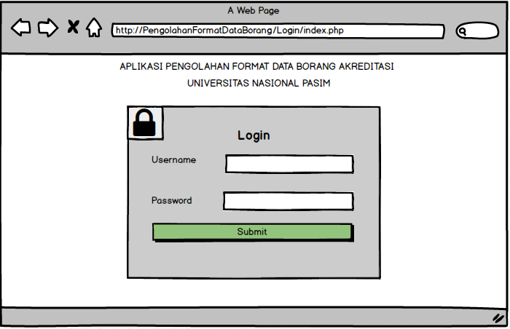

**Gambar 4.30** Tampilan login

1. Tampilan Halaman Kelola Data Fakultas

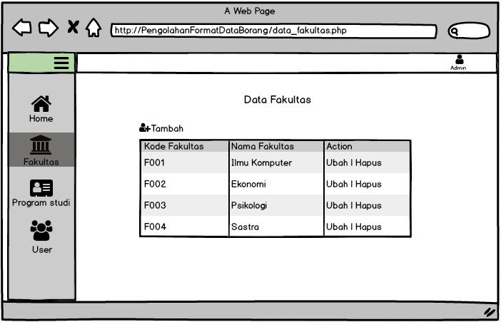

**Gambar 4.31** Tampilan Halaman Kelola Data Fakultas

1. Tampilan Halaman Tambah Data Fakultas

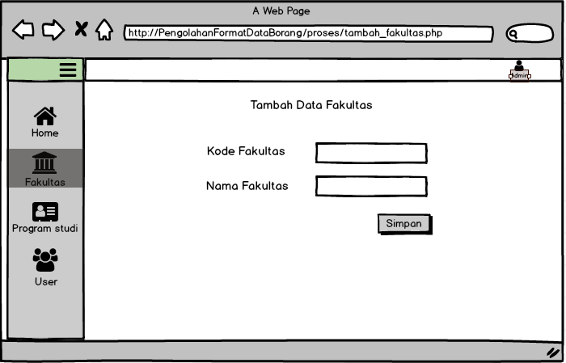

**Gambar 4.32** Tampilan Halaman Tambah Data Fakultas

4. Tampilan Halaman Ubah Data Fakultas

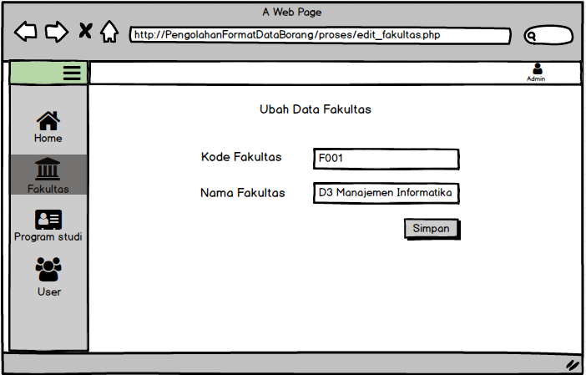

**Gambar 4.33** Tampilan Halaman Ubah Data Fakultas

1. Tampilan Halaman Hapus Data Fakultas

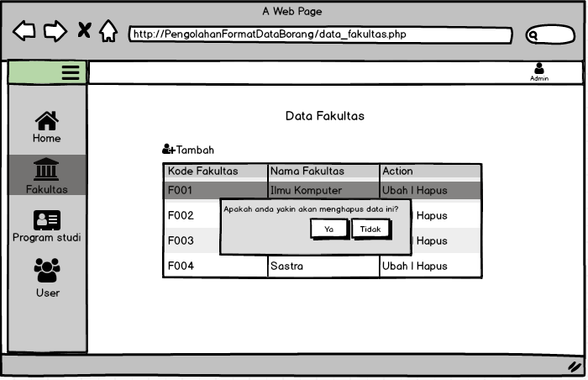

**Gambar 4.34** Tampilan Halaman Hapus Data Fakultas

1. Tampilan Halaman Kelola Data Program Studi 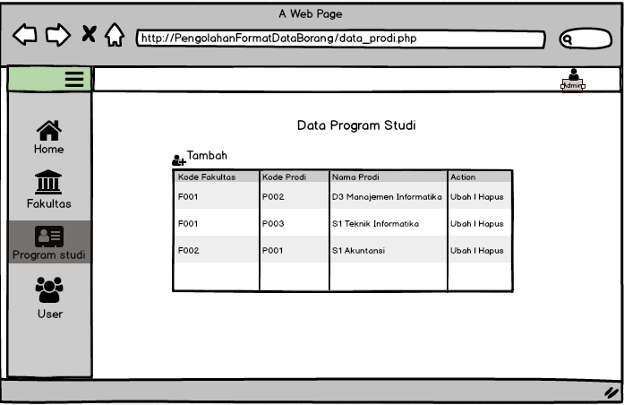

**Gambar 4.34** Halaman Kelola Data Program Studi

1. Tampilan Form Tambah Data Program Studi

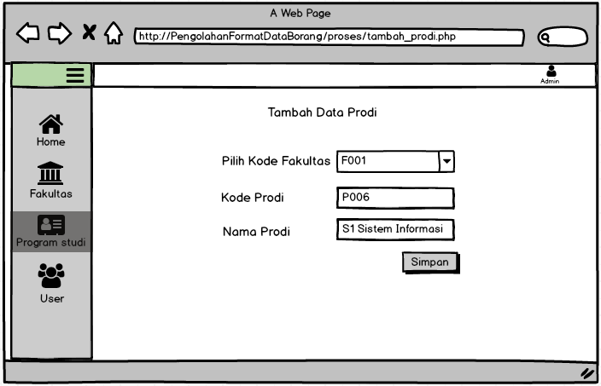

**Gambar 4.35** Tampilan Form Tambah Data Program Studi

1. Tampilan Form Ubah Data Program Studi

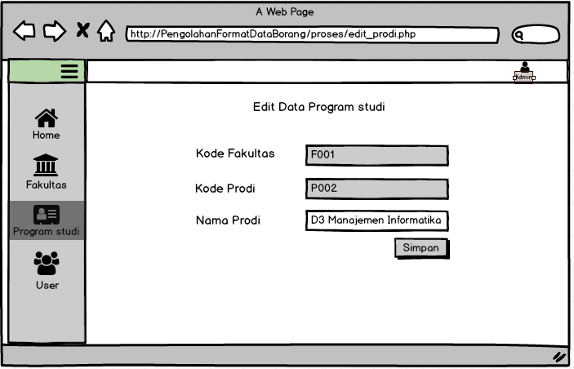

**Gambar 4.36** Tampilan Form Ubah Data Program Studi

1. Tampilan Halaman Hapus Data Program Studi

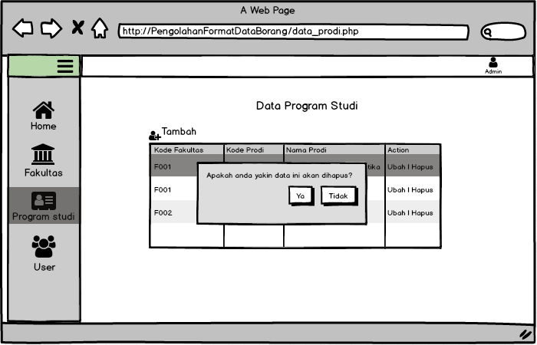

**Gambar 4.37** Tampilan Halaman Hapus Data Program Studi

1. Tampilan Halaman Data User

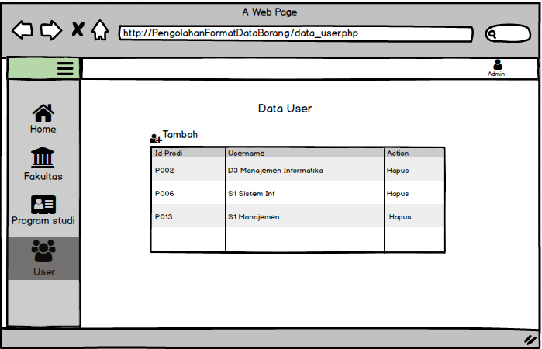

**Gambar 4.38** Tampilan Halaman Data User

1. Tampilan Halaman Tambah Data User

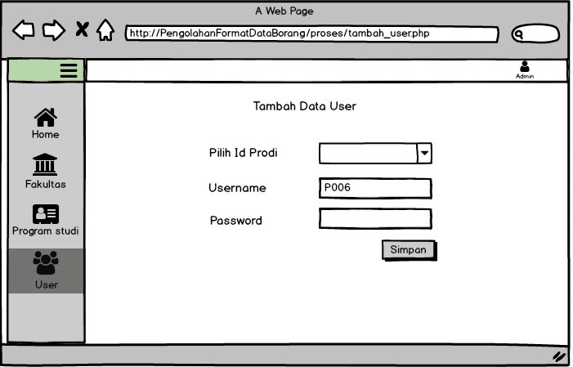

**Gambar 4.39** Tampilan Halaman Tambah Data User

1. Tampilan Halaman Hapus Data User

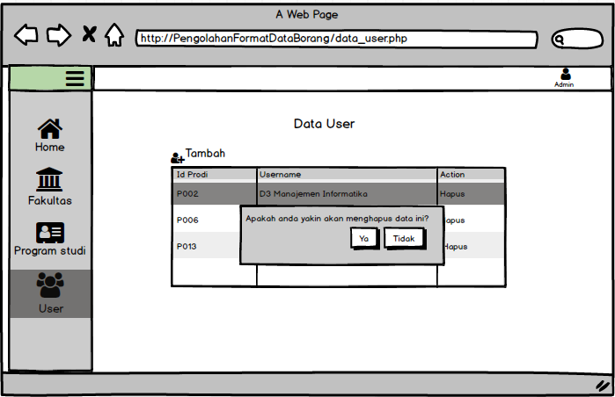

**Gambar 4.40** Tampilan Halaman Hapus Data User

1. Tampilan Halaman Utama Data Borang

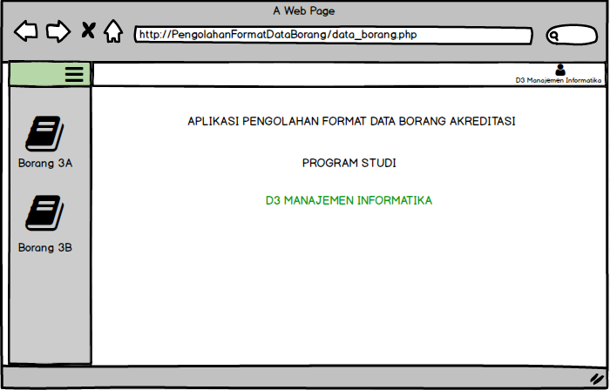

**Gambar 4.41** Tampilan Halaman Utama Data Borang

1. Tampilan Halaman Data Borang A 3.1.1 Profil Mahasiswa dan Lulusan

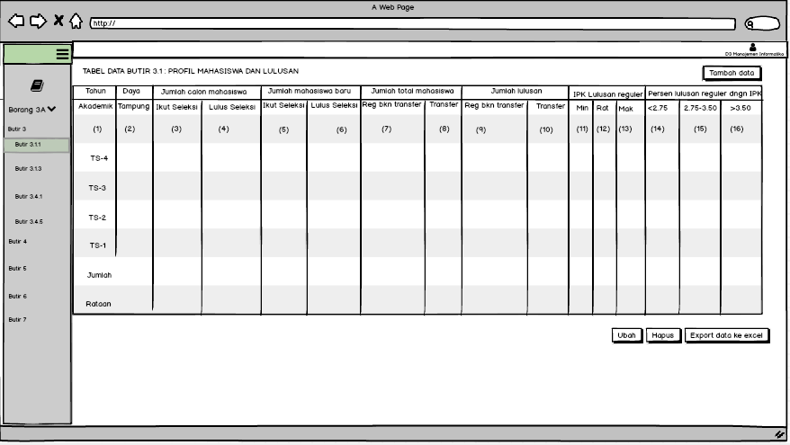

**Gambar 4.42** Tampilan Halaman Data Borang A 3.1.1 Profil Mahasiswa dan Lulusan

1. Tampilan Halaman Data Borang A 3.4.1 Evaluasi Lulusan

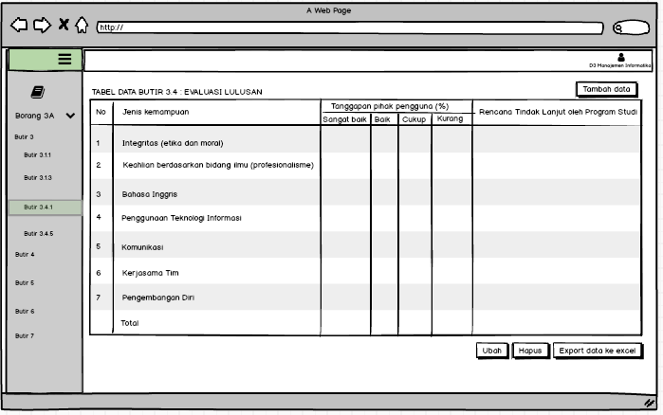

**Gambar 4.43** Tampilan Halaman Data Borang A 3.4.1 Evaluasi Lulusan

1. Tampilan Halaman Tambah data borang A3.4.1 Evaluasi Lulusan

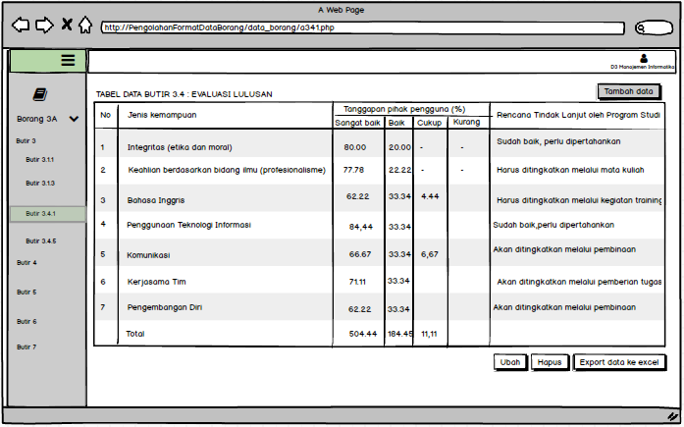

**Gambar 4.44** Tampilan Halaman Tambah Data Borang A 3.4.1 Evaluasi Lulusan

1. Tampilan Halaman Ubah data borang A3.4.1 Evaluasi Lulusan

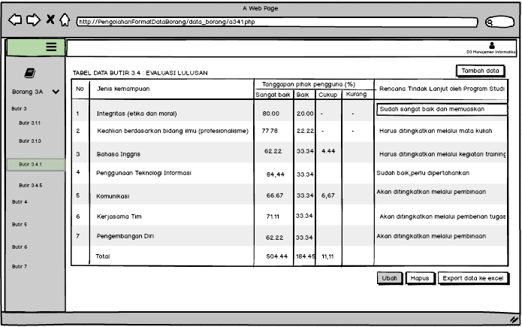

**Gambar 4.45** Tampilan Halaman Ubah Data Borang A 3.4.1 Evaluasi Lulusan

1. Tampilan Halaman Hapus data borang A3.4.1 Evaluasi Lulusan

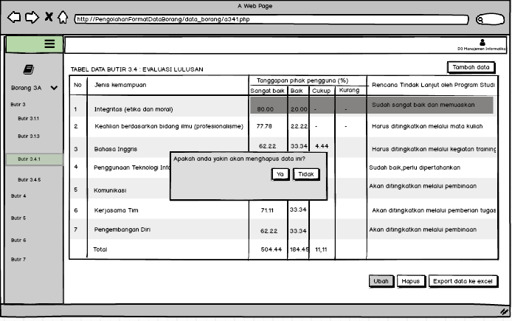

**Gambar 4.46** Tampilan Halaman Hapus Data Borang A 3.41 Evaluasi Lulusan